5th Dec. 2025



2025
Navigating Responsible Marketing in the Digital Era
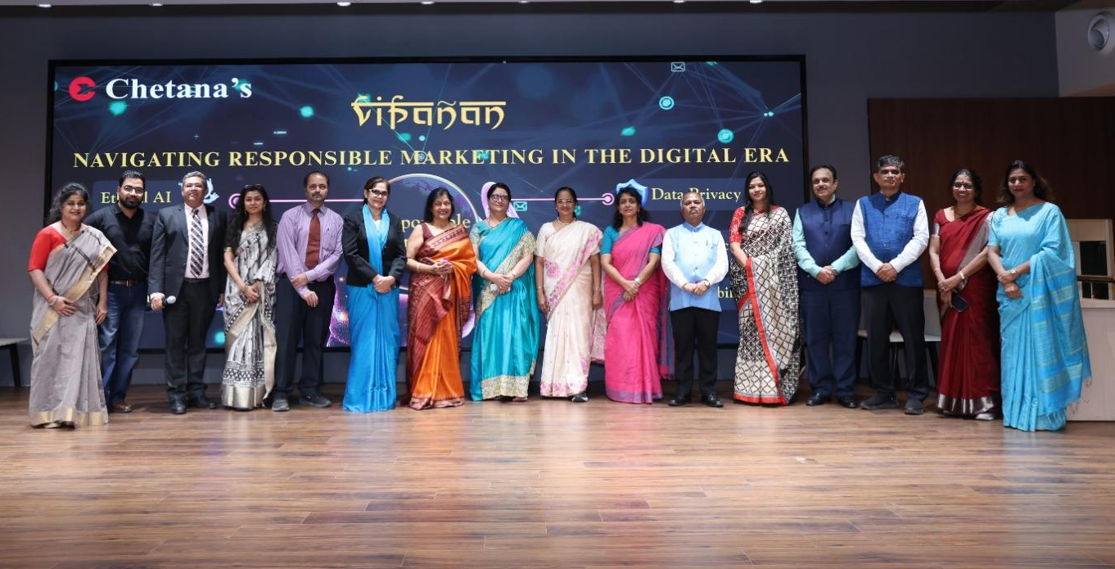
Our Pillars of Marketing Specialisation

Friday, 05th December 2025
Vipanan 2025, the annual marketing conclave of Chetana’s Institutes, was organized on 5 December 2025 with the central theme “Navigating Responsible Marketing in the Digital Era.” This year, the event focused on a theme of growing global relevance- Responsible Marketing in the Digital Era. Responsible marketing is an unspoken expectation from all stakeholders. With AI-powered personalization, data-driven decision making, and immersive digital experiences, marketing has become more powerful.
The full-day event brought together industry leaders, marketing professionals, and academic experts to discuss the evolving responsibilities of brands in an era shaped by artificial intelligence, sustainability concerns, data ethics, and heightened consumer expectations.
The conclave aimed to provide students with real-world insights, strengthen academia industry linkages, and emphasize the importance of ethical and transparent marketing practices.

Session Highlights

Address by Mr. Shubhro Bose

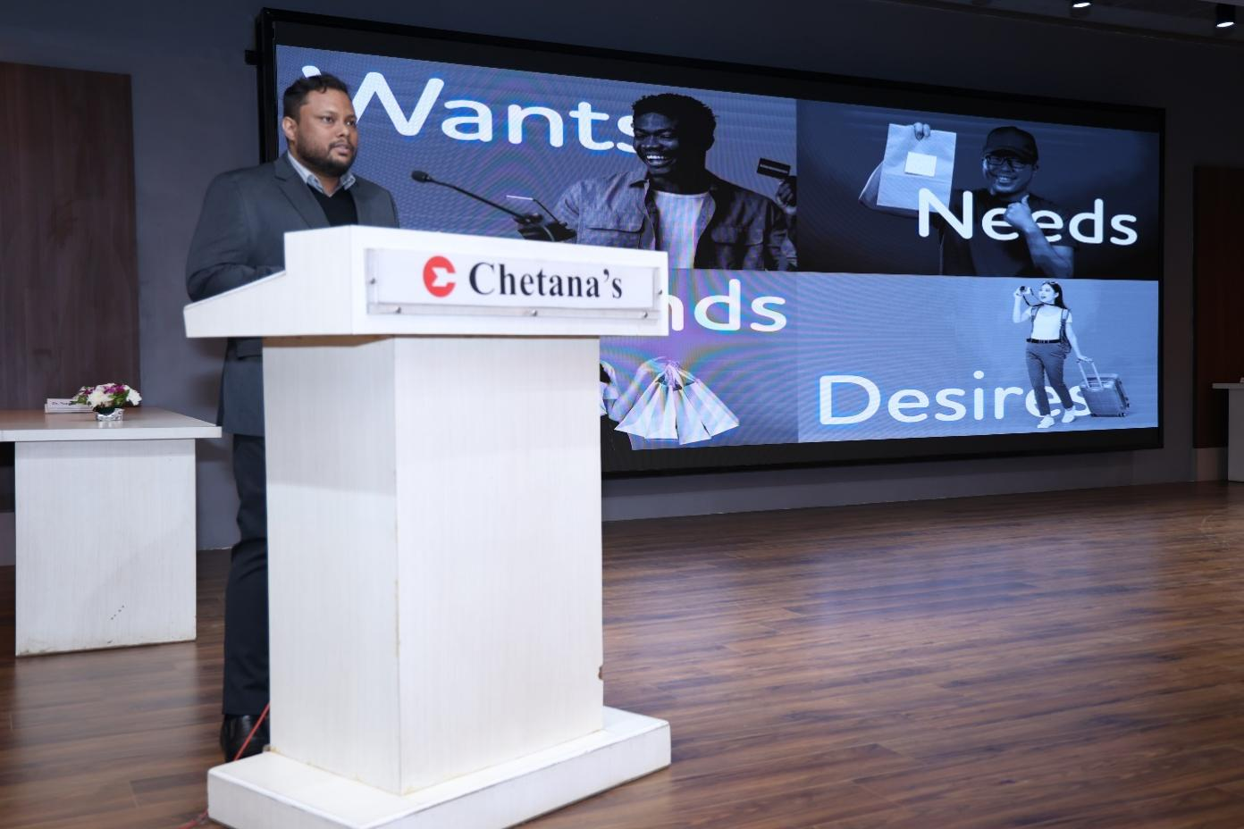

Keynote Speaker: Mr Shubhro Bose, Industry Brand Head- CBG, TCS
Mr. Bose introduced the concept of the Adaptive Perpetual Enterprise, illustrating how organizations must continuously evolve in a rapidly changing digital landscape.
Highlights included:
- Examples of AI applications such as Google Gemini, LinkedIn enhancements, and Coca-Cola’s AI-powered campaigns.
- AI should serve as a copilot, not an autopilot, maintaining human oversight and creativity.
- Brand examples like P&G and Fevicol to demonstrate content integrity and long-term brand trust.
He stressed that responsible deployment of AI is essential for preserving brand credibility.

Address by Mr. Vinay Khamkar

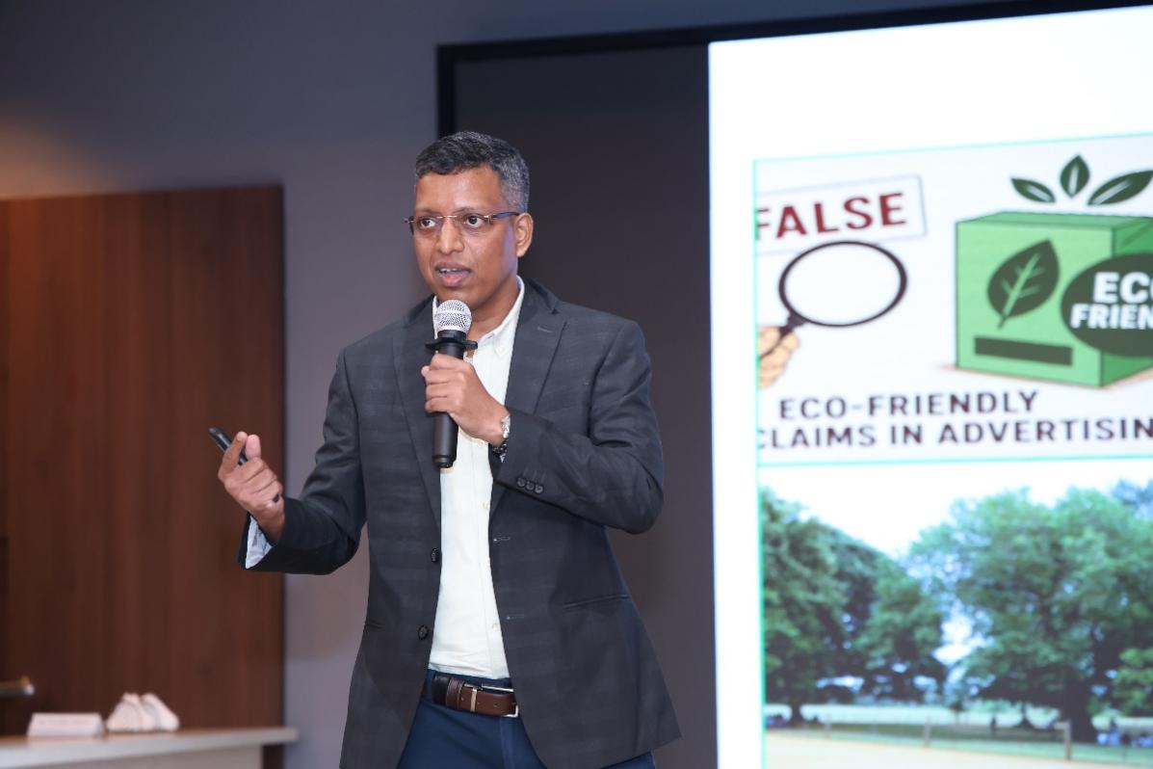

Keynote Speaker: Mr. Vinay Khamkar, Partner, DigiVibe
Mr. Vinay Khamkar delivered an insightful session on Green Marketing vs. Greenwashing, focusing on the rising relevance of sustainability claims in advertising.
Key points discussed included:
- Understanding green claims and why brands misuse them.
- ASCI’s guidelines and recent reviews on misleading environmental claims.
- Why storytelling resonates deeply in the Indian market.
- Positive case studies: ITC Sunfeast’s 100% paper packaging, Patagonia’s sustainability focus, Tata Power Solar Roof, DHL x Coldplay sustainable tour collaboration.
- Negative examples illustrating greenwashing: Surf Excel, Godrej Knight, Bharat Petroleum, Sprite, and Adani Renewables.
His talk emphasized the need for authenticity in sustainability narratives.

Keynote Address by Mr. Vikram Murkute

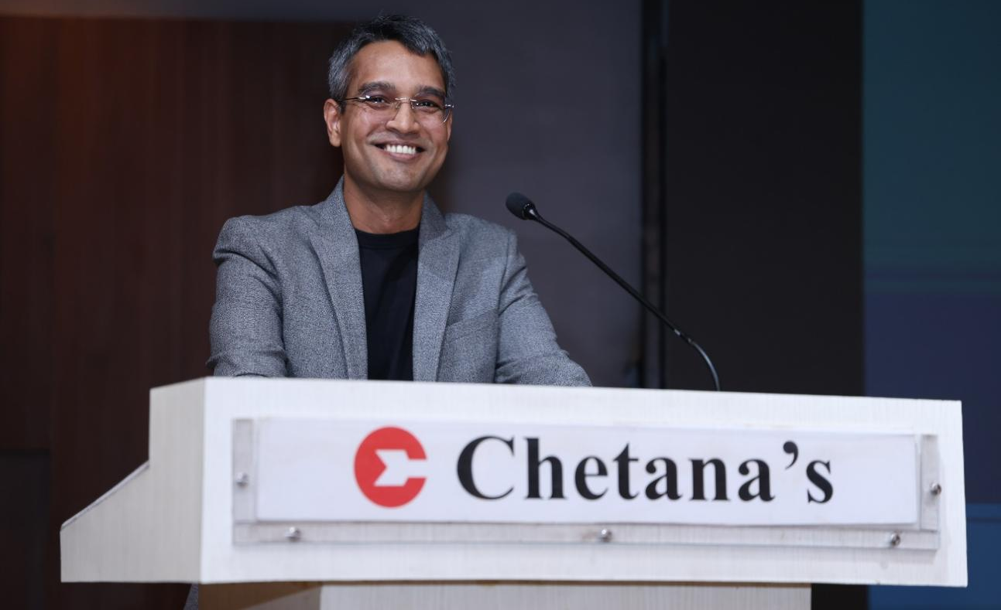

Keynote Speaker: Mr. Vikram Murkute, SVP & Head- Brand & Marketing, Axis AMC
Mr. Murkute discussed the fundamentals of marketing and the rising importance of responsible communication.
Using popular examples such as Maggi and Cadbury, he highlighted how brand trust can be built—or destroyed. He also referenced the Axis Mutual Fund advertisement to explain evolving consumer expectations and the accountability brands must uphold in their messaging.

Address by Guest of Honour

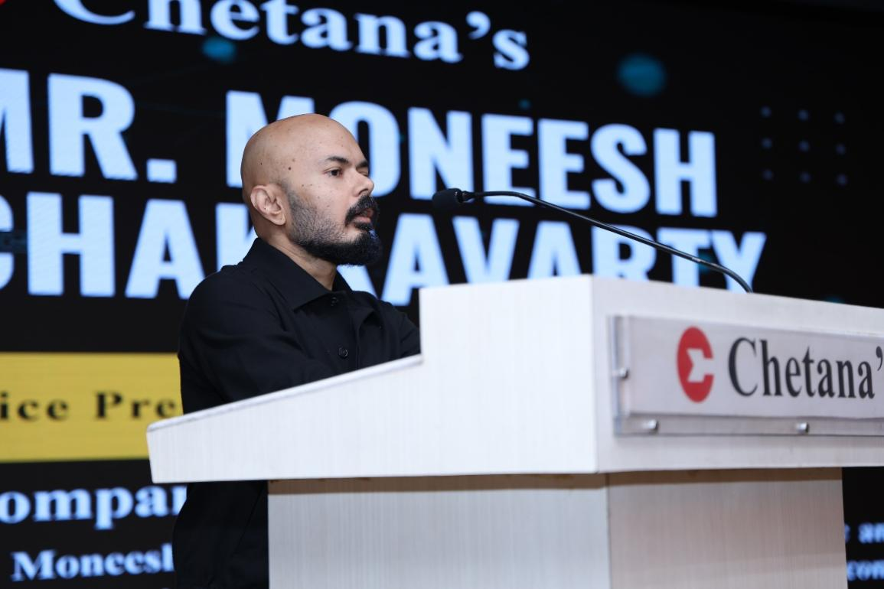

Keynote Speaker: Mr. Moneesh Chakravarty, VP, Marketing Head, Business Standard

Mr. Chakravarty focused on brand integrity and transparency in the digital era.
Key themes included:
- Development of brand personality as a strategic asset.
- The role of AI as an enabler and equalizer across industries.
- Importance of strong storytelling to capture attention in an era of short attention spans.

Coffee Table Conversation

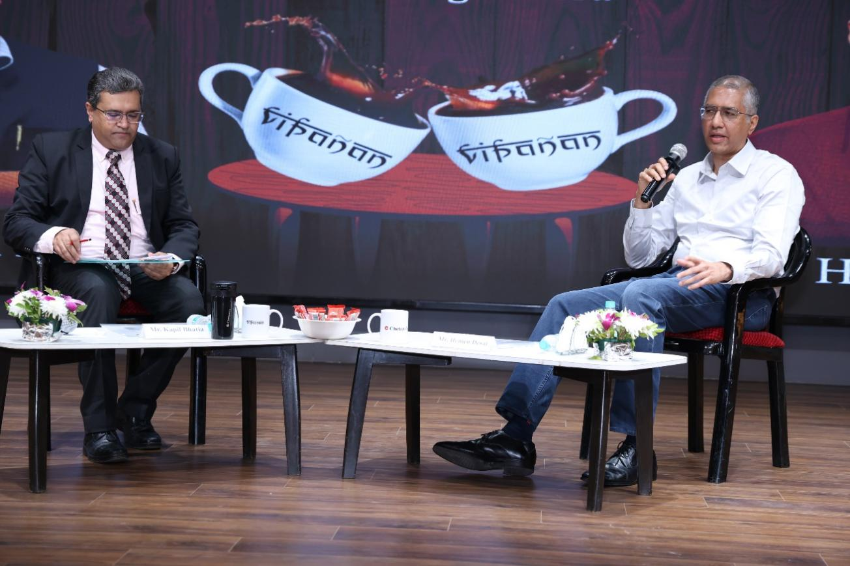

A dynamic conversation between Mr. Kapil Bhatia and Mr. Hemen Desai
The conversation explored:
- Responsibilities of brand agencies
- Challenges in ethical advertising
- Importance of data privacy and user well-being on digital platforms
- Regulations surrounding surrogate advertising
This interactive format provided practical insights into the ethical dilemmas faced in modern marketing.

Student Competitions
Panel Discussion Competition
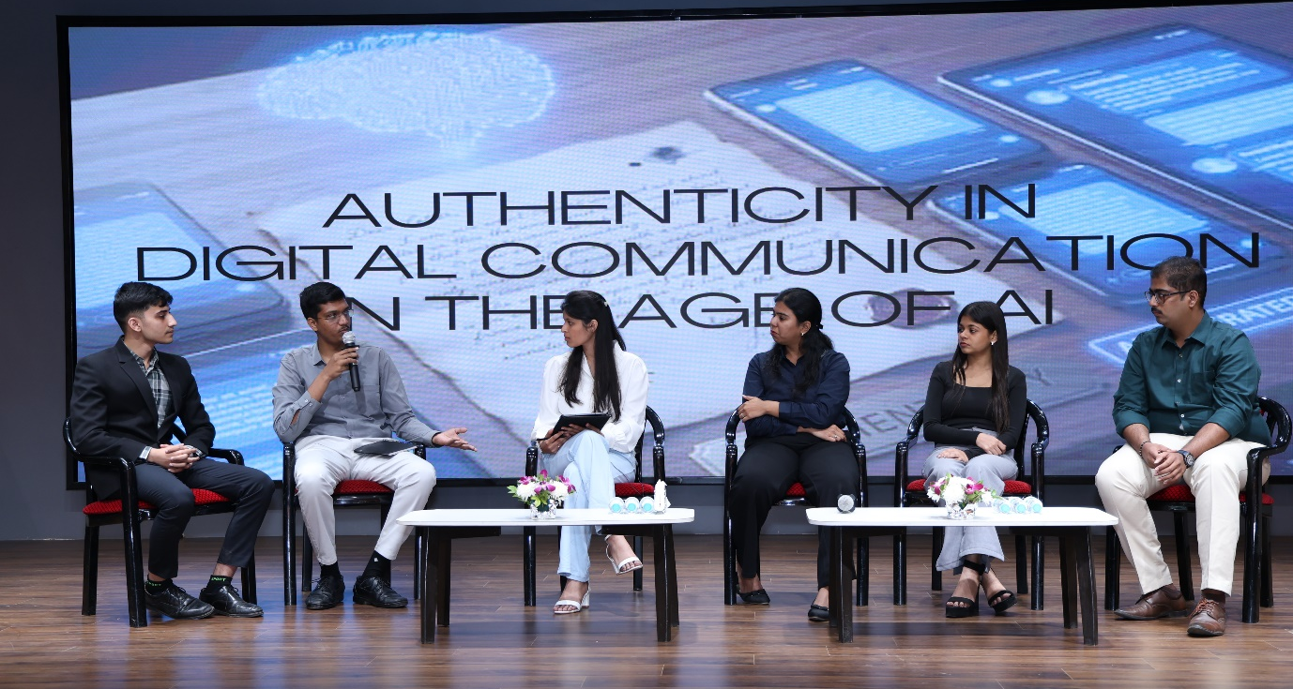
Panel Discussion ‘Authenticity in Digital Communication in the Age of AI’
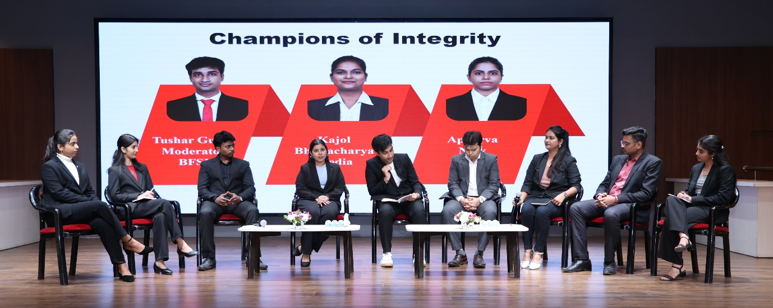
Panel Discussion ‘Responsible Marketing in Digital Era’
Guided by Prof. Reetu Bhatia, students engaged in a panel discussion on responsible marketing themes, demonstrating critical thinking and analytical skills. There were two teams, one was from PGDM and another was from MMS.

Prize distribution to Storyboard Video Competition Participants
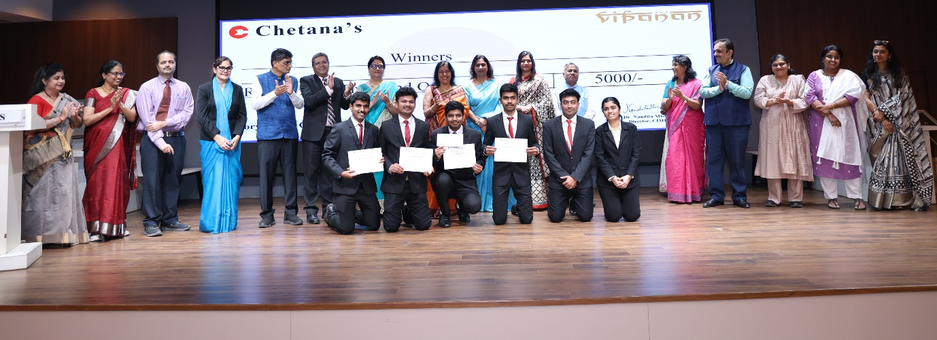
Winners of Story Board Competition
Winners of Panel Discussion
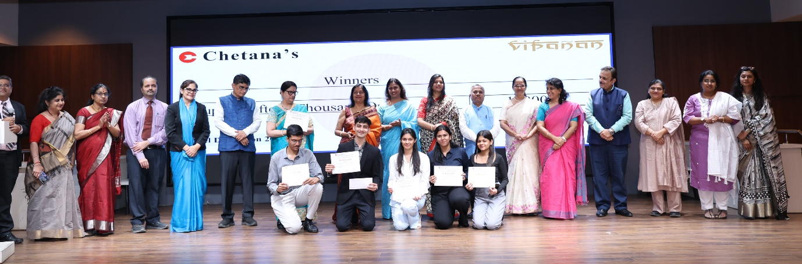

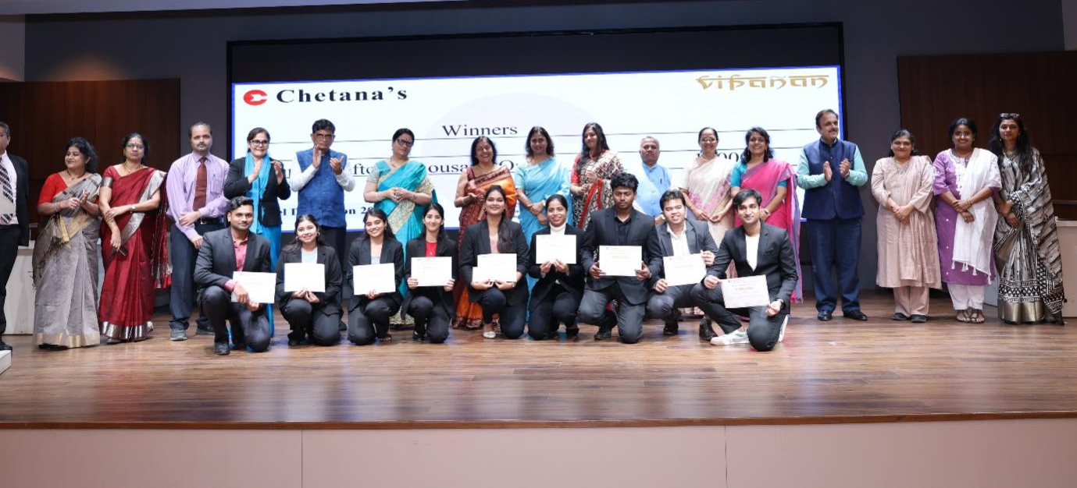
Introduced by Prof. Pankaj Kulkarni, the storyboard segment showcased creative interpretations of the conclave theme through visual storytelling.
Prizes were awarded to both the teams of Panel discussions as well as Storyboard competition. Panel discussion winners received the sum of Rs. 15,000/- as prize amount.

5. Closing Ceremony

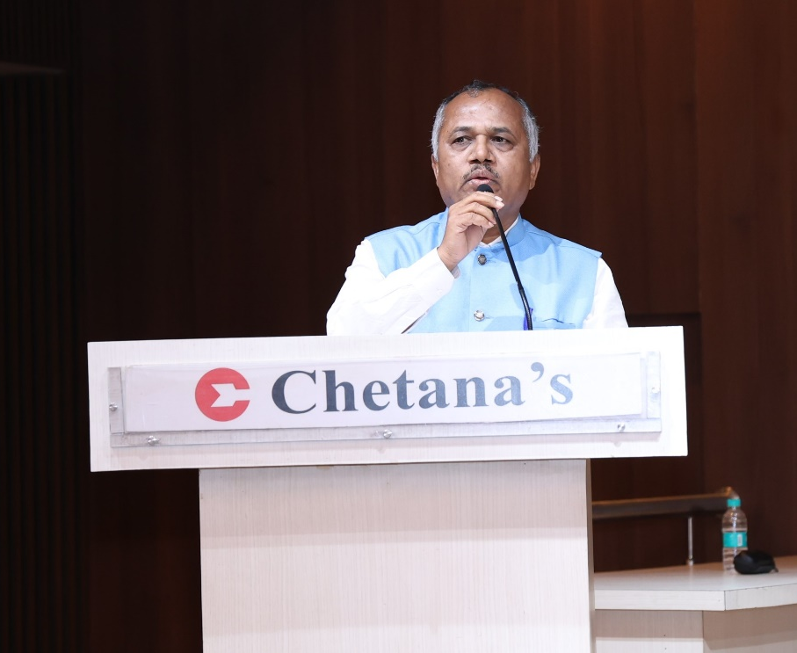
The event ended with a vote of thanks by Dr. Balaji Sadavarte
The event concluded with a wrap-up and Vote of Thanks delivered by Dr. Balaji Sadavarte, acknowledging the contributions of the dignitaries, faculty, support staff, student committees, and participants. Vipanan 2025 successfully fostered learning, dialogue, and inspiration around the future of responsible marketing.

