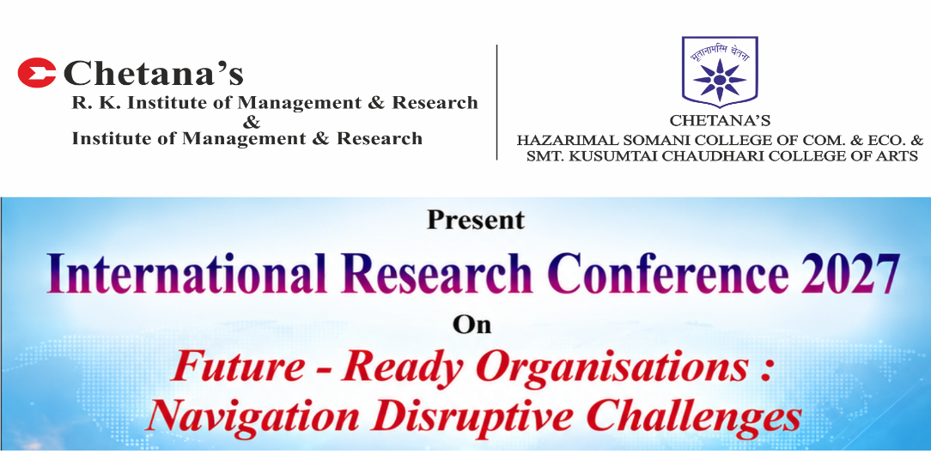
21st & 22nd January 2027

Organisations today operate in an environment defined by accelerating technological change, volatile markets, shifting workforce expectations, and intensifying climate and geopolitical uncertainty. Disruption is no longer episodic; it is a continuous feature of the business landscape. For organisations to remain competitive and relevant, future readiness has become a strategic imperative rather than an aspirational goal. It calls for leadership maturity that can anticipate change, build adaptive capacity, and align people, processes, and technology toward long-term resilience.
Being future-ready goes beyond adopting new technologies or restructuring operations. It requires organisations to cultivate agility in strategy, strengthen governance and risk foresight, and build a culture that embraces continuous learning and innovation. At the management level, this translates into rethinking leadership models, decision-making frameworks, and talent strategies to ensure organisations can navigate uncertainty while sustaining performance, trust, and stakeholder value. It also calls for a balanced approach that integrates digital transformation with human capability, ensuring that disruption is managed responsibly and inclusively.
Among the many dimensions of disruption, the rise of Artificial Intelligence stands out as both an opportunity and a test of organisational maturity. AI readiness is not merely a technology adoption curve; it is the ability of organisations to integrate intelligent systems while keeping human judgment, ethics, and oversight central to decision-making. This calls for a deliberate focus on the human dimension: reskilling the workforce, redesigning roles for human-AI collaboration, and nurturing leadership that can guide teams through this transition with empathy and clarity. Organisations that succeed will be those that treat AI as an enabler of human potential rather than a replacement for it, ensuring that innovation strengthens, rather than erodes, trust, wellbeing, and organisational culture.
At the heart of this transformation lies a simple but powerful principle: AI must be built for people, not in place of them., The pursuit of advanced AI is only worthwhile when it genuinely benefits humanity and remains guided by human oversight, a philosophy increasingly echoed across global business and policy circles. For organisations, this means adoption decisions should not be driven by technological capability alone, but by whether AI genuinely strengthens human potential, dignity, and wellbeing. Future readiness, therefore, is not just about how fast organisations adopt AI, but how thoughtfully they align it with human values, ensuring technology remains a means to empower people, not a force that displaces them.
While the opportunities presented by disruption are significant, organisations face real challenges in building this readiness, including resistance to change, capability and skill gaps, legacy structures, and the pace at which emerging technologies evolve. Addressing these challenges requires deliberate investment in leadership development, organisational design, and a forward-looking research agenda that translates academic insight into practical management action.
The conference theme, "Future Ready Organisations: Navigating Disruptive Challenges," reflects the urgent need for organisations to build the foresight, agility, and resilience required to thrive amid continuous disruption. Central to this readiness is the way organisations embrace change - be it technological, economic, social, or environmental, not merely as a force to adapt to, but as an opportunity that must remain aligned with human values, genuinely benefiting people and staying guided by sound judgment. True future readiness lies in ensuring that innovation empowers people rather than displaces them, and this calls for a new breed of leadership, one that leads with foresight, empathy, and ethical clarity to steer organisations confidently through disruption, today and in the years ahead.
Chetana’s International Research Conference aims to bring together academics, industry leaders, policymakers, and research scholars to exchange ideas, showcase research, share best practices, and deliberate on future pathways toward building resilient and future ready organisations. Through keynote addresses, panel discussions, and research presentations, the conference seeks to explore how businesses and academia can collaboratively contribute to advancing organisational excellence and sustainable growth in a disruptive world.
The conference aims to:
- Encourage dialogue and collaboration among academia, industry, policymakers, and social enterprises to co-create frameworks that strengthen organisational agility and future readiness.
- Promote research and knowledge-sharing on disruption management, organisational resilience, and adaptive leadership through empirical research, emerging trends, and case studies.
- Facilitate discussions on leadership mind-sets, governance mechanisms, and policy frameworks that help organisations balance performance with responsibility amid continuous change.
- Examine the role of emerging technologies and digital transformation in reshaping business models, decision-making, and competitive advantage.

Registration Link : CALL FOR PAPERS

